Hoath Parish Council
Financial information 2014/15

Payments over £100

Date | Amount | Purpose
7 April 2014 | 340.48 | Salaries/expenses
7 April 2014 | 203.21 | Subscription
12 May 2014 | 346.98 | Salaries/expenses
12 May 2014 | 441.16 | Insurance
12 May 2014 | 120.00 | Internal audit
9 June 2014 | 112.00 | Grass cutting
9 June 2014 | 418.32 | Salaries/expenses
9 June 2014 | 140.00 | I.T.
14 July 2014 | 343.73 | Salaries/expenses
14 July 2014 | 640.00 | Grounds maintenance
31 July 2014 | 343.73 | Salaries/expenses
8 September 2014 | 340.48 | Salaries/expenses
8 September 2014 | 250.00 | Rent
8 September 2014 | 112.00 | Grass cutting
13 October 2014 | 359.41 | Salaries/expenses
13 October 2104 | 120.00 | Rent
10 November 2014 | 38.53 | Salaries/expenses
15 December 2014 | 438.53 | Salaries/expenses
15 December 2014 | 110.00 | Rent
12 January 2015 | 345.32 | Salaries/expenses
9 February 2015 | 345.32 | Salaries/expenses
9 March 2015 | 345.32 | Salaries/expenses

Annual return

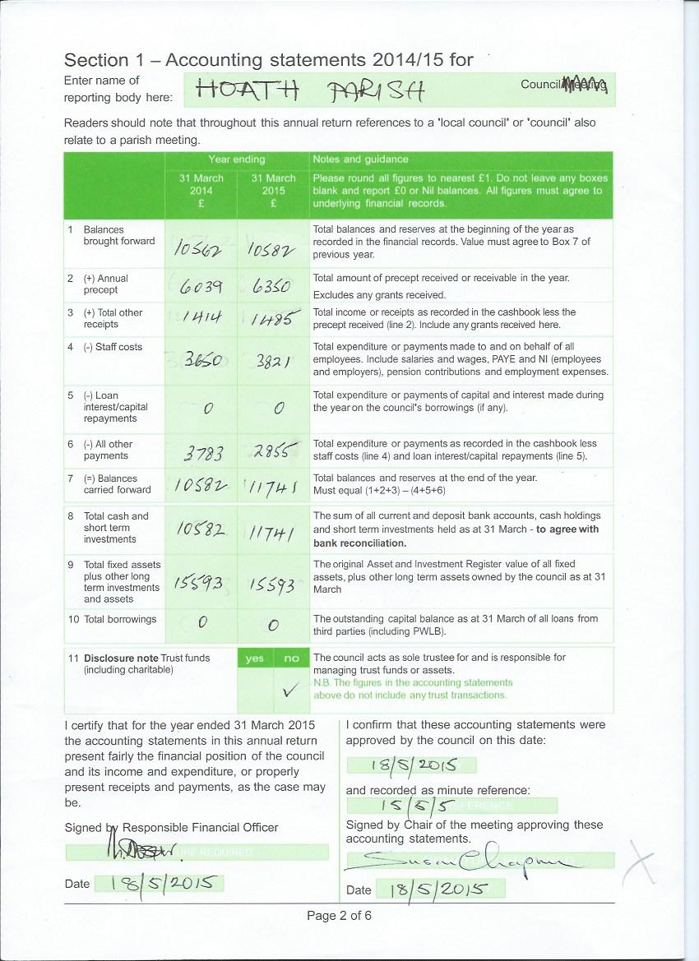

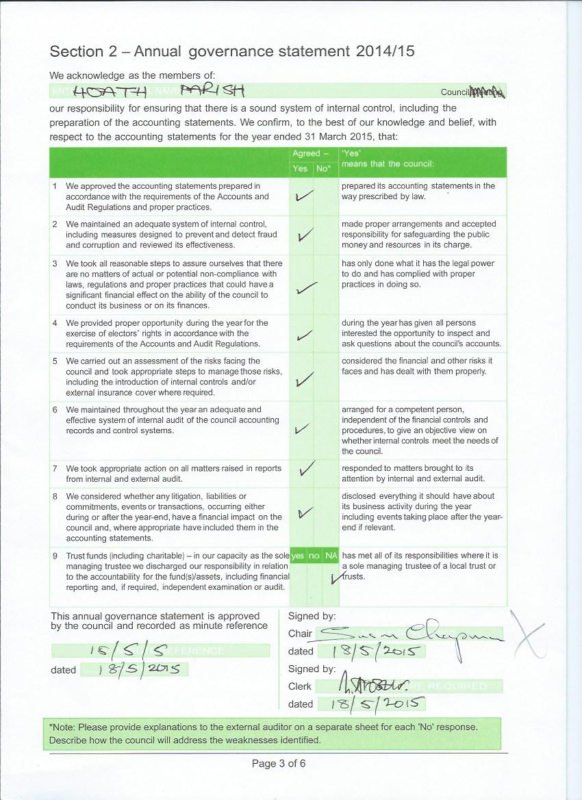

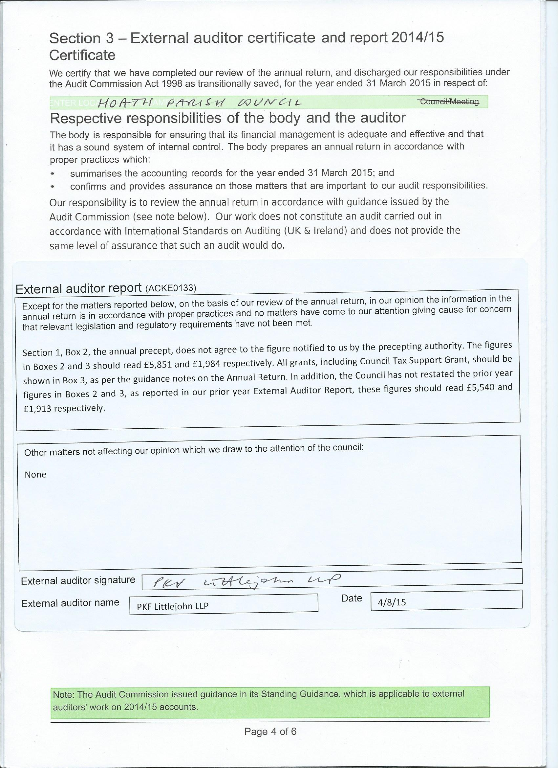

Comment from Hoath PC:

The auditor’s comment above refers to the fact that a couple of years ago, the government changed the way that local authorities were funded for “council tax support grant”. This means that rather than being automatically included within the precept we receive from CCC, it is (in theory) a separate item. However, it is all paid as one lump sum and the “precept” request from the PC to CCC is for just one figure. So technically, the auditor may be correct but to split this sum into two components is arguably confusing. There is no effect on the overall financial position – it is just a switch between two lines.

